**ECE3051 – Analog and Digital Signal Processing, Fall Semester 2022-2023**

**ELA DA – 3, Slot: L25-L26**

**By: Jonathan Rufus Samuel (20BCT0332) Date: 07.10.2022**

__________________________________________________________________________________

**ELA DA 3 – DOS: 09.10.2022**

**Task - 3: Realization of OFDM waveforms**

**Q1) For the given OFDM system generate the waveforms corresponding to each block:**

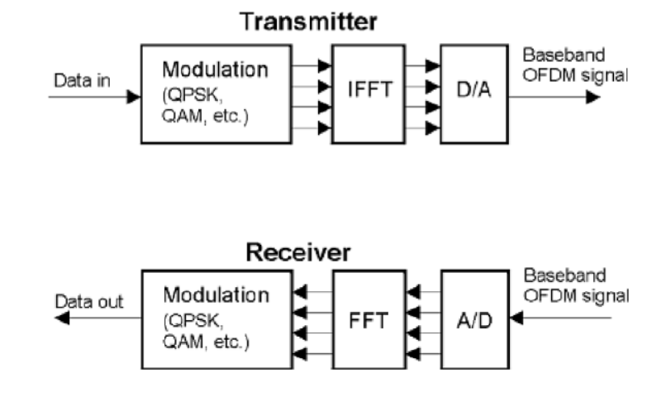

**CODE:**

%Task - 3: Realization of OFDM Waveforms

%Name: Jonathan Rufus Samuel (20BCT0332)

%Course: ECE3051 - ELA

%For the given OFDM system, generate the waveforms corresponding to each

%block.

%-----Transmitter-------

%1) Base Signal (Data in):

syms x(n);

x(n) = 1/pi * (2*sin(9*pi*n/10) - sin(8*pi*n/10));

t = -50:50; %t = -20:20;

subplot(421),plot(t,x(t));

title('Signal x(n) - Data In/Base Signal');

xlabel('time (t)');

ylabel('Magnitude (x(n))');

grid;

%2) Signal after QPSK/QAM modulation transform (here choose QAM)

fs = 20;

t = -50:50;

x1 = modulate(double(x(t)),5,fs,'amssb');

subplot(422),stem(t,x1);

title('Signal x1(n) - Signal after QAM Modulation');

xlabel('time (t)');

ylabel('Magnitude (x1(n))');

grid;

%3) Signal after Inverse Discrete Fourier Transform (IFFT)

x2 = ifft(x1);

t = -50:50;

subplot(423),stem(t,x2);

title('Signal x2(n) - Signal after Inverse Fourier Transform');

xlabel('time (t)');

ylabel('Magnitude (x2(n))');

grid;

%4) Signal after Digital to Analog Conversion

x3 = x2;

subplot(424),plot(t,x3);

title('Signal x3(n) - Signal after conversion to Analog');

xlabel('time (t)');

ylabel('Magnitude (x3(n))');

grid;

%i.e. Data in ----> Baseband OFDM Signal

%-----Receiver-------

%5) Signal after Analog to Digital Conversion

%i.e. Baseband OFDM Signal ----> Data Out

y = x3;

subplot(425),stem(t,y);

title('Signal y(n) - Signal after conversion to Digital');

xlabel('time (t)');

ylabel('Magnitude (y(n))');

grid;

%6) Signal after Discrete Fourier Transform (FFT)

y1 = fft(y);

t = -50:50;

subplot(426),plot(t,y1);

title('Signal y1(n) - Signal after Fourier Transform');

xlabel('time (t)');

ylabel('Magnitude (y1(n))');

grid;

%7) Signal after QPSK/QAM modulation transform (here choose QPSK)

fs = 20;

t = -50:50;

y2 = modulate(double(y1),5,fs,'amssb');

subplot(427),stem(t,y3);

title('Signal y2(n) - Signal after QAM De-Modulation');

xlabel('time (t)');

ylabel('Magnitude (y2(n))');

grid;

%8) Final Data Out Signal after various stages of transmission

y3 = y2;

t = -50:50;

subplot(428),plot(t,y3);

title('Signal y3(n) - Data Out Signal');

xlabel('time (t)');

ylabel('Magnitude (y3(n))');

grid;

**OUTPUT:**

>> %Task - 3: Realization of OFDM Waveforms

%Name: Jonathan Rufus Samuel (20BCT0332)

%Course: ECE3051 - ELA

%For the given OFDM system, generate the waveforms corresponding to each

%block.

%-----Transmitter-------

%1) Base Signal (Data in):

syms x(n);

x(n) = 1/pi * (2*sin(9*pi*n/10) - sin(8*pi*n/10));

t = -50:50; %t = -20:20;

subplot(421),plot(t,x(t));

title('Signal x(n) - Data In/Base Signal');

xlabel('time (t)');

ylabel('Magnitude (x(n))');

grid;

%2) Signal after QPSK/QAM modulation transform (here choose QAM)

fs = 20;

t = -50:50;

x1 = modulate(double(x(t)),5,fs,'amssb');

subplot(422),stem(t,x1);

title('Signal x1(n) - Signal after QAM Modulation');

xlabel('time (t)');

ylabel('Magnitude (x1(n))');

grid;

%3) Signal after Inverse Discrete Fourier Transform (IFFT)

x2 = ifft(x1);

t = -50:50;

subplot(423),stem(t,x2);

title('Signal x2(n) - Signal after Inverse Fourier Transform');

xlabel('time (t)');

ylabel('Magnitude (x2(n))');

grid;

%4) Signal after Digital to Analog Conversion

x3 = x2;

subplot(424),plot(t,x3);

title('Signal x3(n) - Signal after conversion to Analog');

xlabel('time (t)');

ylabel('Magnitude (x3(n))');

grid;

%i.e. Data in ----> Baseband OFDM Signal

%-----Receiver-------

%5) Signal after Analog to Digital Conversion

%i.e. Baseband OFDM Signal ----> Data Out

y = x3;

subplot(425),stem(t,y);

title('Signal y(n) - Signal after conversion to Digital');

xlabel('time (t)');

ylabel('Magnitude (y(n))');

grid;

%6) Signal after Discrete Fourier Transform (FFT)

y1 = fft(y);

t = -50:50;

subplot(426),plot(t,y1);

title('Signal y1(n) - Signal after Fourier Transform');

xlabel('time (t)');

ylabel('Magnitude (y1(n))');

grid;

%7) Signal after QPSK/QAM modulation transform (here choose QPSK)

fs = 20;

t = -50:50;

y2 = modulate(double(y1),5,fs,'amssb');

subplot(427),stem(t,y3);

title('Signal y2(n) - Signal after QAM De-Modulation');

xlabel('time (t)');

ylabel('Magnitude (y2(n))');

grid;

%8) Final Data Out Signal after various stages of transmission

y3 = y2;

t = -50:50;

subplot(428),plot(t,y3);

title('Signal y3(n) - Data Out Signal');

xlabel('time (t)');

ylabel('Magnitude (y3(n))');

grid;

Warning: Using only the real component of complex data.

> In matlab.graphics.chart.internal.getRealData (line 52)

In stem (line 40)

Warning: Imaginary parts of complex X and/or Y arguments ignored.

Warning: Using only the real component of complex data.

> In matlab.graphics.chart.internal.getRealData (line 52)

In stem (line 40)

Warning: Imaginary parts of complex X and/or Y arguments ignored.

Warning: HILBERT ignores imaginary part of input.

> In hilbert>hilbert_ml (line 58)

In hilbert (line 40)

In modulate (line 125)

Warning: Using only the real component of complex data.

> In matlab.graphics.chart.internal.getRealData (line 52)

In stem (line 40)

Warning: Imaginary parts of complex X and/or Y arguments ignored.

>>

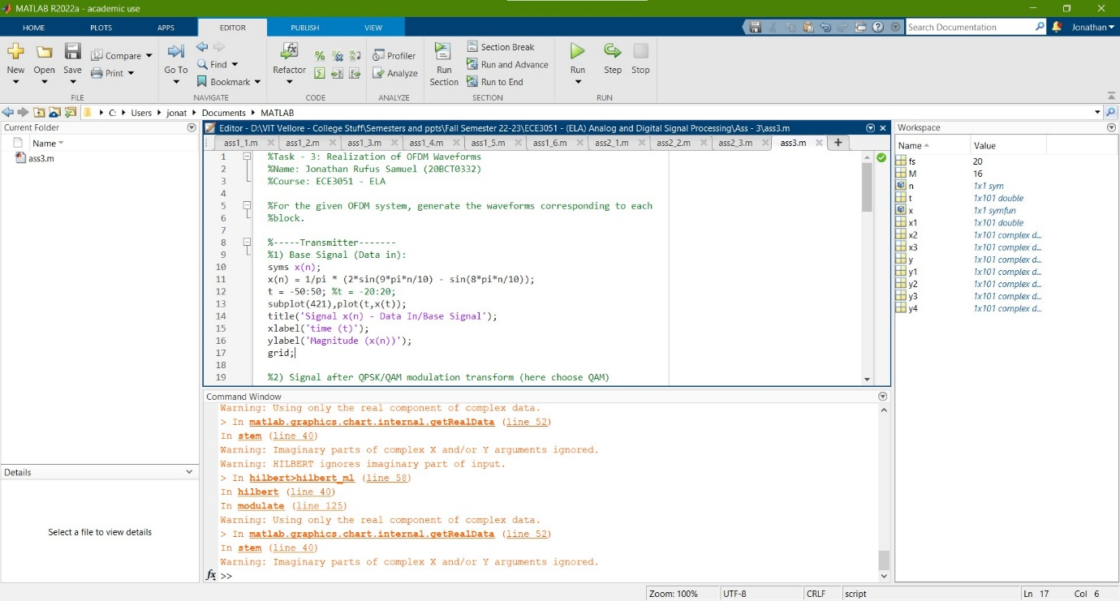

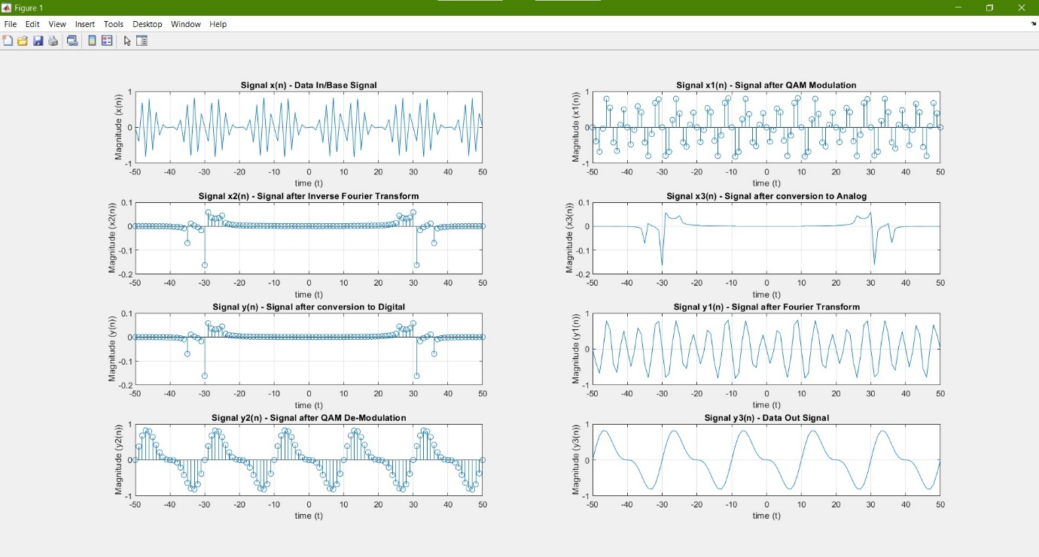

**WORKING OUT:**



